IMAGE FIBREGLASS INDUSTRIES LLC
BE WITH US FOR A BETTER IMAGE

PROVIDING HIGH GRADE GRP, GRC, PREFAB PRODUCTS SINCE 2000

Reliability Meets Quality
🌟 Vision
To be a leading innovator and trusted provider of GRP, GRC, GRG, and prefab solutions—shaping modern infrastructure, enriching lifestyles, and delivering long-term value across regional and global markets.

🎯 Mission
At Image Fibreglass Industries LLC, our mission is to design, manufacture, and deliver high-quality GRP, GRC, GRG, PVC, and modular portacabin solutions that exceed client expectations. Through precision, innovation, and sustainable practices, we aim to build a better image in every project we touch.

💡 Core Values
- Quality Excellence
We are committed to delivering durable, reliable, and aesthetically superior products.
- Innovation
We embrace new materials, methods, and technologies to stay ahead in composite construction solutions.
- Customer Focus
Our clients are at the heart of everything we do — we listen, adapt, and deliver with integrity.
- Sustainability
We aim to reduce environmental impact through responsible production and resource-conscious design.
- Safety & Compliance
We prioritize safety in every step, ensuring all our products meet local and international standards.
- Teamwork
We believe in building strong internal and external partnerships, empowering people to grow together.
- Reliability & Trust
We honor our commitments and build relationships based on trust, transparency, and consistency.

⭐ Why Image?
At Image Fibreglass Industries LLC, we don’t just deliver products — we build trust, durability, and design into every solution. With a proven track record in GRP, GRC, GRG, PVC products, and modular portacabins, we combine cutting-edge manufacturing with deep industry knowledge to bring your vision to life.
Here's why clients choose Image:
🔹 Unmatched Quality
We follow stringent quality control at every stage — ensuring strength, finish, and long-term reliability.
🔹 Custom Solutions
Whether it’s architectural cladding, decorative elements, or prefab cabins, we tailor each product to your specifications.
🔹 On-Time Delivery
We respect your timelines. Our efficient workflow and experienced team ensure prompt, dependable service.
🔹 End-to-End Expertise
From design and engineering to fabrication and installation, we provide complete project support under one roof.
🔹 Sustainability-Driven
Our materials and methods support eco-conscious building practices — safer, greener, and future-ready.
🔹 Strong After-Sales Support
We believe in long-term partnerships. Our service doesn't end with delivery — we’re here whenever you need us.

Be With Us for a Better Image — because when precision meets performance, your project stands out.

ABOUT US
IMAGE FIBREGLASS INDUSTRY is the market leader in the UAE’s fiberglass sector. Our company specializes in designing and manufacturing high-quality GRP, GRC, GRG, and prefab portable cabins. Our well-trained technicians, using advanced technology, provide our clients with products of the highest quality, in accordance with British standards.
We have been market leaders for over 20 years, with more than 100 employees, establishing a benchmark through our focus on excellence, leadership, and integrity. We closely monitor every aspect of our operations, including strict quality control, on-time delivery, safety, and environmental concerns.
GRP
GRP (Glass Reinforced Plastic) is a highly versatile and durable material widely used in construction and industrial applications. It is particularly well-suited for architectural features such as domes, vaults, minarets, and car park structures. At IMAGE FIBREGLASS INDUSTRY, we manufacture GRP products to meet stringent international standards, offering end-to-end solutions including consultancy, custom design, and professional installation services.
GRC
GRC (Glass Fiber Reinforced Concrete) is a high-performance building material widely used in modern architecture for both structural and decorative applications. Renowned for its strength, design flexibility, and lightweight properties, GRC has become a preferred choice in contemporary construction projects across the industry
PORTABLE CABINS
Portable cabins offer a flexible, cost-effective solution for temporary or semi-permanent space requirements. Designed for quick installation and easy relocation, they are ideal for use as site offices, accommodation units, security cabins, classrooms, and more. Built with durable materials and customizable features, our portable cabins combine functionality, comfort, and efficiency—making them a smart choice for a wide range of industries.

SERVICES
- GRP Sectional Panel Tank
- Cylindrical Water Tanks
- Septic Tanks & Soak Away
- Car Parking Shed
- Acrylic Baath &Shower Trays
- Bathtubs
- Shuttering Moulds
- Plastic Tanks
- Electrical Enclosure
- A/C Trays

GRP LAMINATION
- Underground RCC Water tank
- Swimming Pool
- Fibre Coating related to field
- Drainage manholes
- Mild steel tank
- Decorative works
- Polyester Doors
- GRP Liner
- GRP Gulley Ports & Traps
- Pipe Lines

GRP PANEL TANKS
We are one of the leading manufacturers of these types of tanks, which are available in various capacities. Our panel tanks are engineered for high performance and tested to meet the highest requirements of BS and ASTM standards. High-quality raw materials are used under strict quality control throughout the entire manufacturing process.
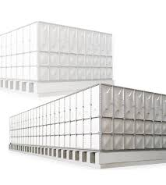

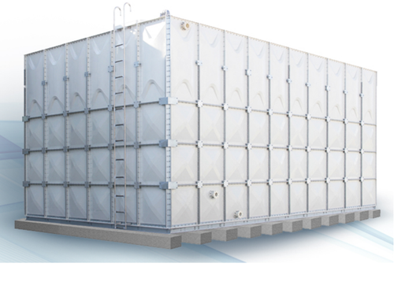
GRP HORIZONTAL TANKS
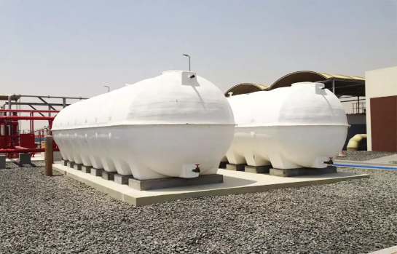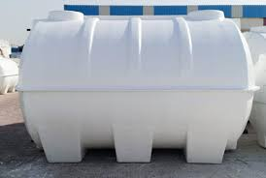
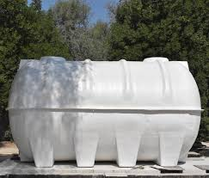
GRP CYLINDRICAL/ VERTICAL TANKS
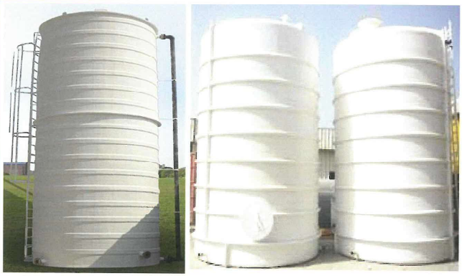
GRP RECTANGULAR CUSTOMIZED WATER TANK

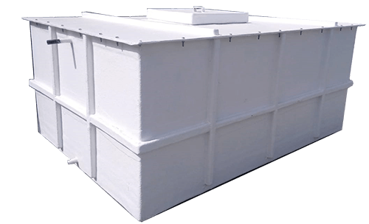

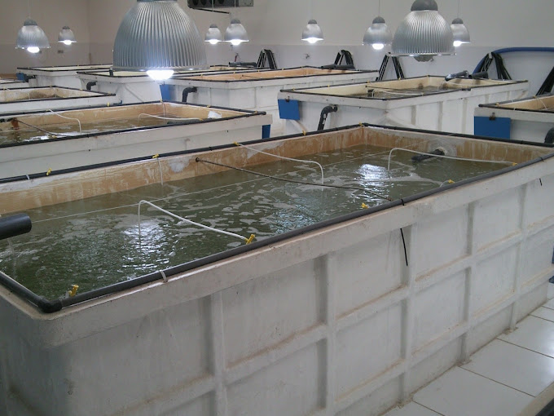 GRP FISH TANK

GRP LINING FOR SWIMMING POOLS
Fibreglass lining or lamination is recommended for the following applications due to its excellent corrosion resistance, durability, and long service life:
- RCC (Reinforced Cement Concrete) tanks
- Swimming pools
- Drainage manholes
- Pipelines
- Mild steel tanks
This method provides a protective barrier against chemical attack, water ingress, and environmental degradation, making it ideal for both industrial and commercial use.

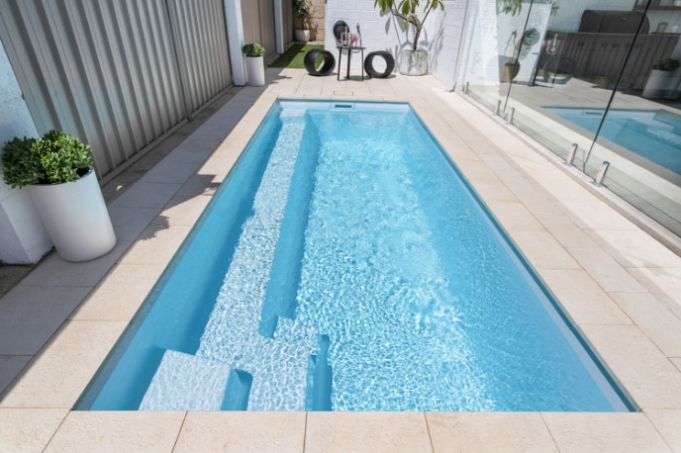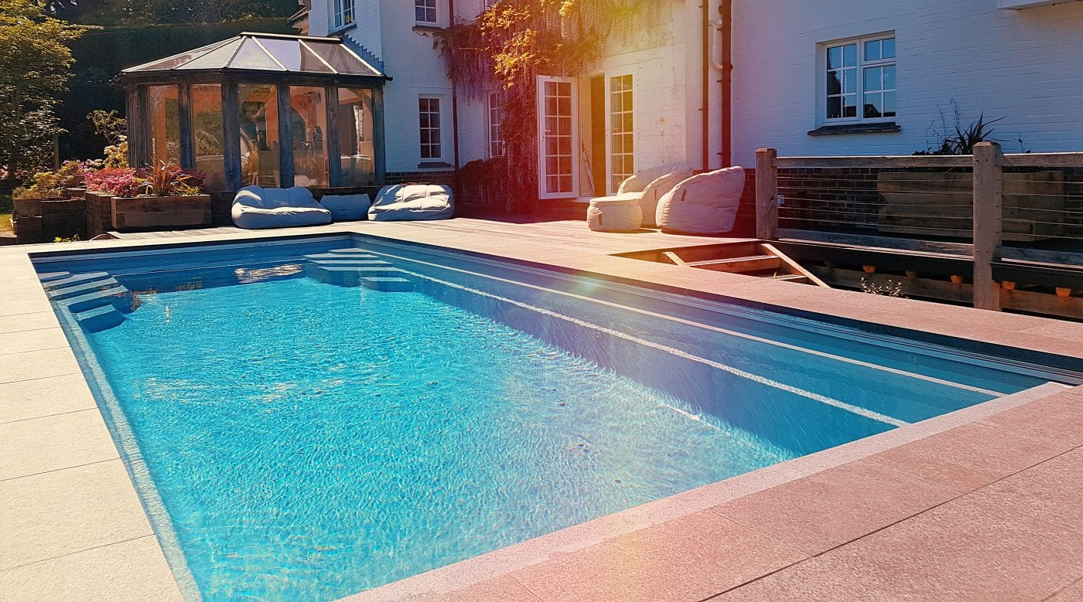
GRP POTS AS PER CUSTOMIZATION
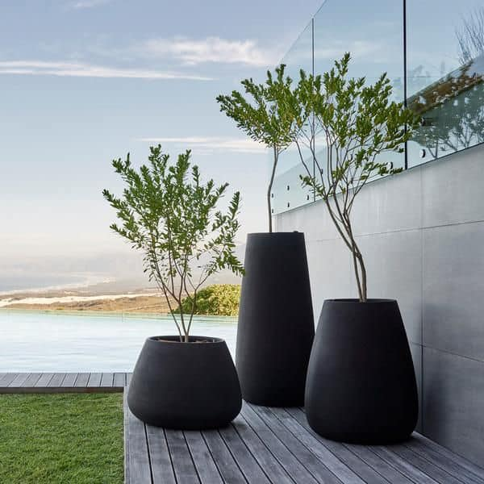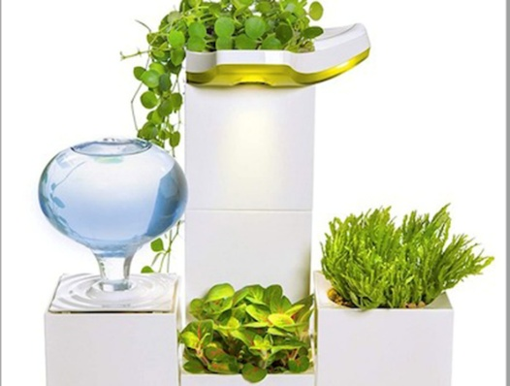

GRP PLANTER BOXES
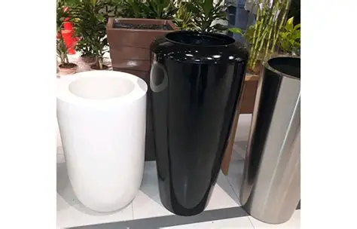 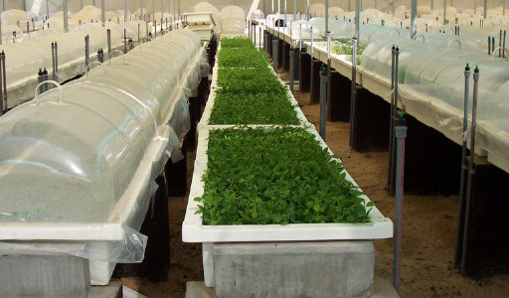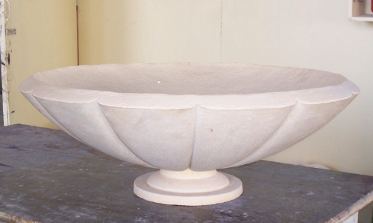 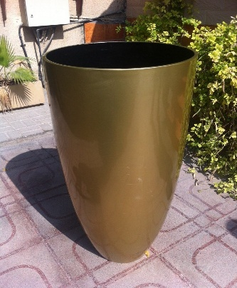
GRP LINING
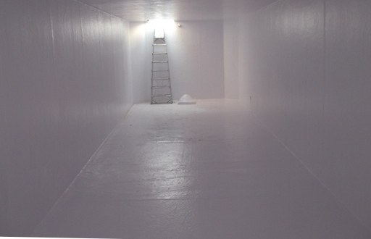
CAR PARKING SHADES
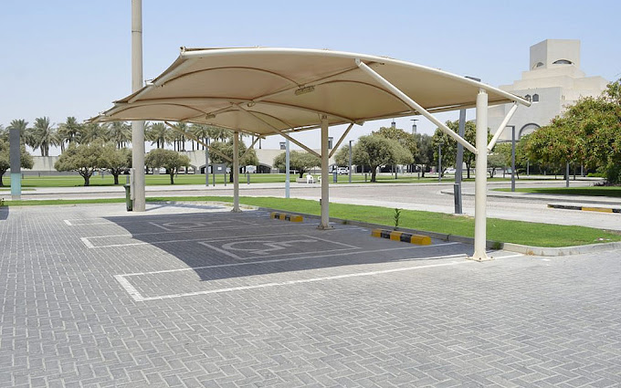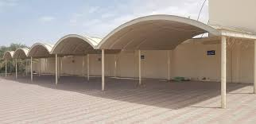

GRP & GRC DOMES
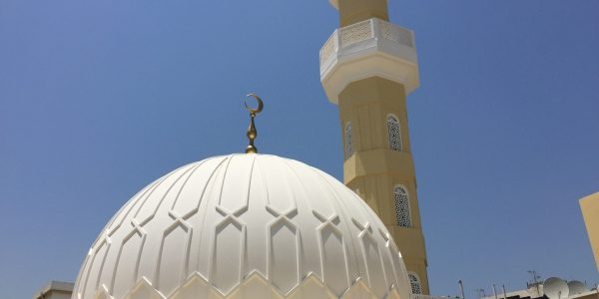

GRP SLIDERS IN PARKS & AMUSEMENT PARKS
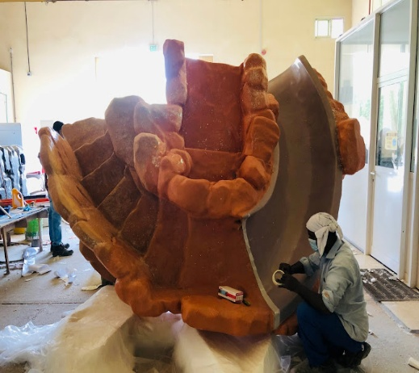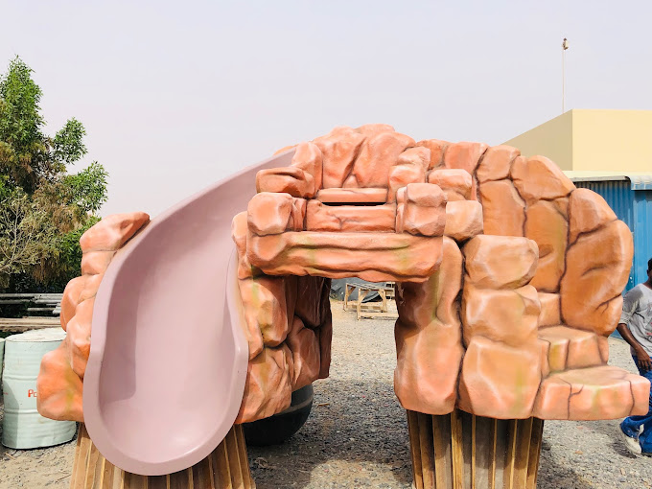

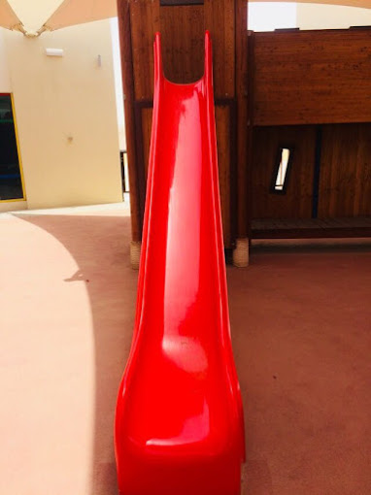
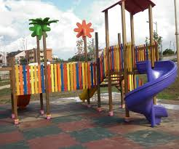
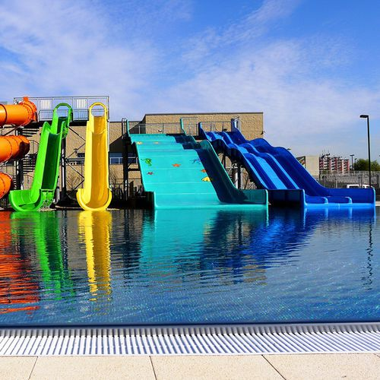
SECURITY CABIN
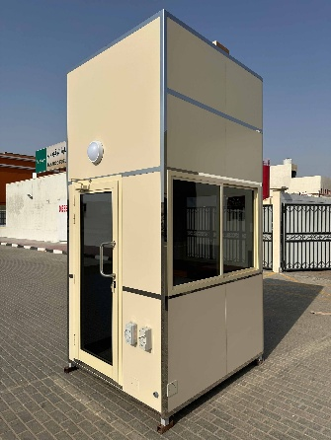
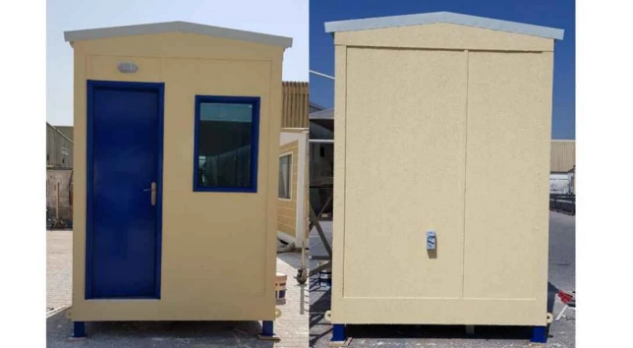

KITCHEN CABIN
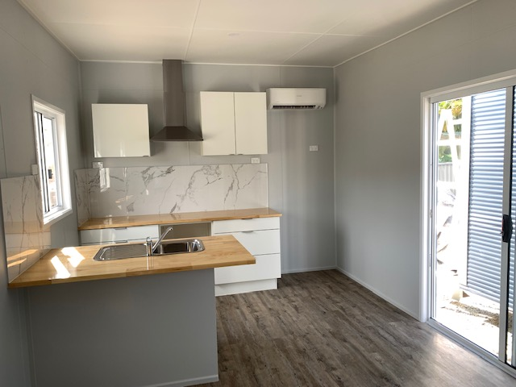
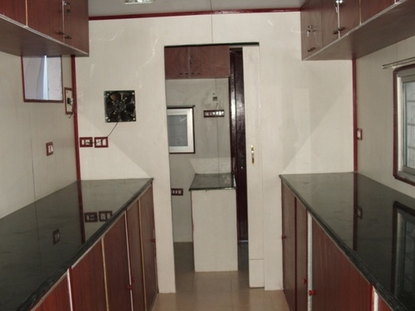

OFFICE CABINS
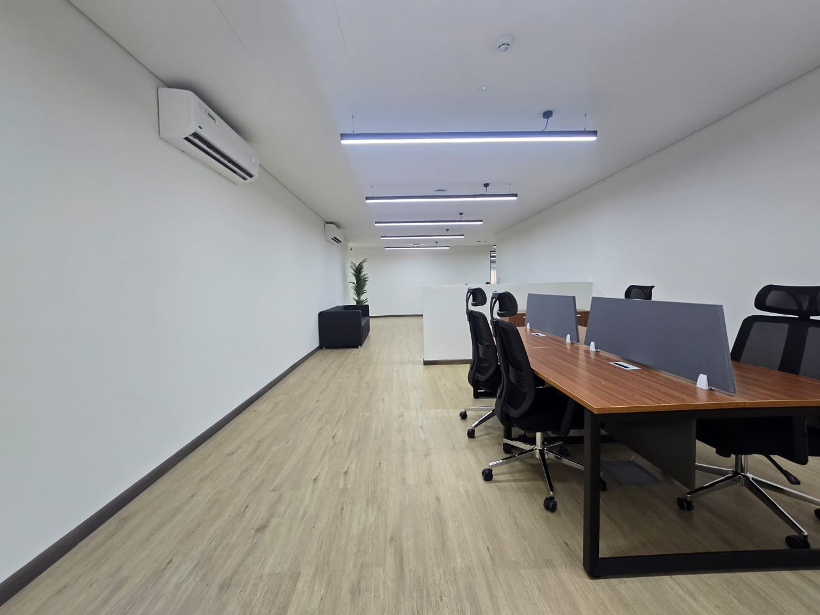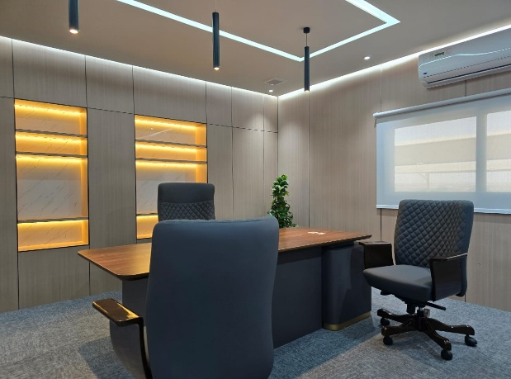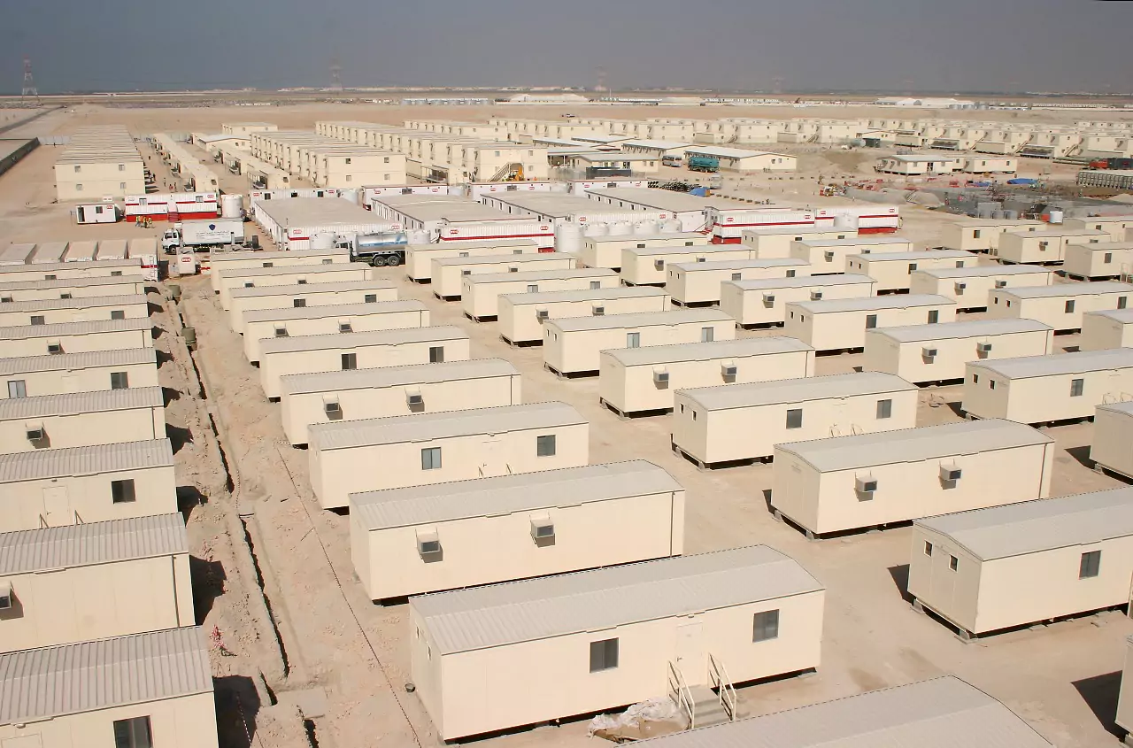

PORTABLE TOILETS
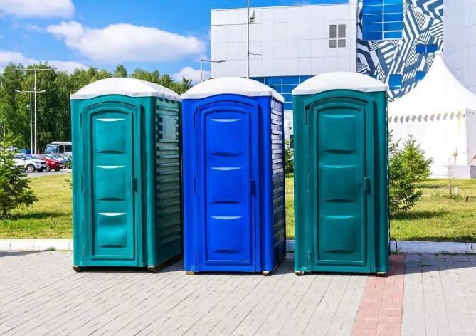
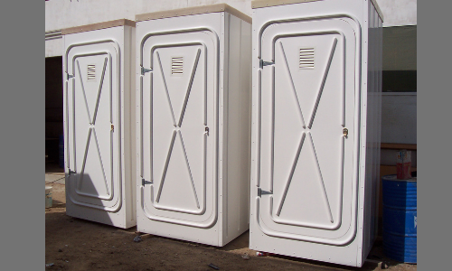
GRP CLADDING
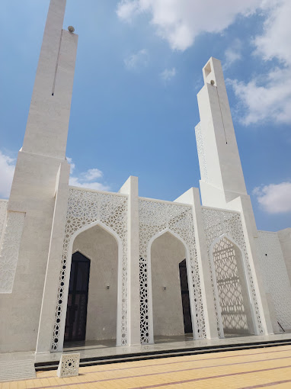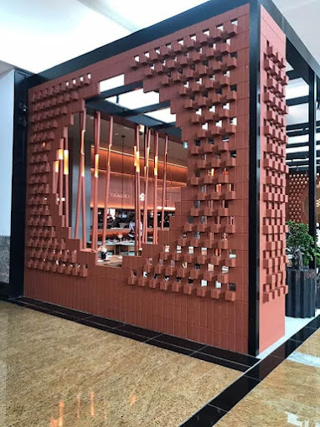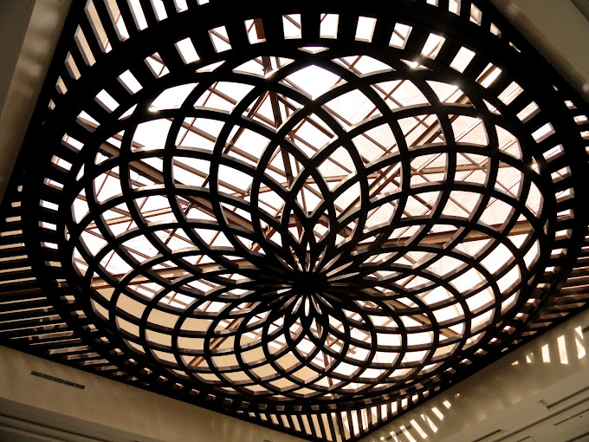
GRC POTS
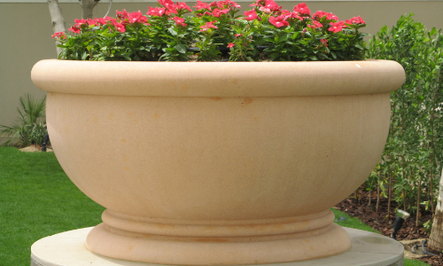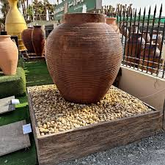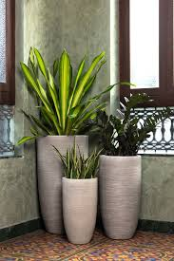

Our Expertise Team
At Image Fibreglass Industry LLC, our strength lies in the expertise and dedication of our diverse team. Each department plays a crucial role in delivering world-class GRP, GRC, GRG, and prefab solutions tailored to meet complex project demands across various sectors.
Engineering Department
Our skilled engineering team specializes in innovative design, structural analysis, and value engineering. With deep knowledge of composite materials and prefab systems, they ensure every solution meets performance, safety, and sustainability standards.
Sales Team
Customer-focused and market-savvy, our sales professionals are equipped with in-depth product knowledge and a strong understanding of project requirements. They work closely with clients to provide tailored solutions and long-term value.
Estimation Team
Accuracy and transparency are the hallmarks of our estimation team. They deliver precise costing and technical proposals, helping clients make informed decisions from the outset of every project.
Procurement & Purchase
Our procurement experts ensure the timely sourcing of quality raw materials and components, maintaining competitive pricing and forging strategic vendor relationships to guarantee uninterrupted project delivery.
Documentation
Efficient documentation support ensures that all technical submittals, compliance documents, and approvals are prepared and delivered in line with project schedules and regulatory standards.
Finance Department
Our finance team ensures robust financial planning, budgeting, and control mechanisms. Their proactive approach enables smooth project execution and supports our commitment to financial integrity and transparency.

Project Management
Experienced project managers oversee each stage of execution, ensuring seamless coordination between departments, adherence to timelines, and achievement of quality benchmarks.
Production Team
Backed by advanced facilities and strict quality controls, our production team translates complex designs into high-performance GRP, GRC, GRG, and prefab products—delivered with precision and efficiency.
HR & Administration
Our HR and administration team fosters a productive, safe, and inclusive workplace, supporting employee growth, training, and compliance with labor standards.
Information Technology (IT)
With robust IT infrastructure and systems in place, our IT department enhances digital collaboration, data security, and operational efficiency across all functions.

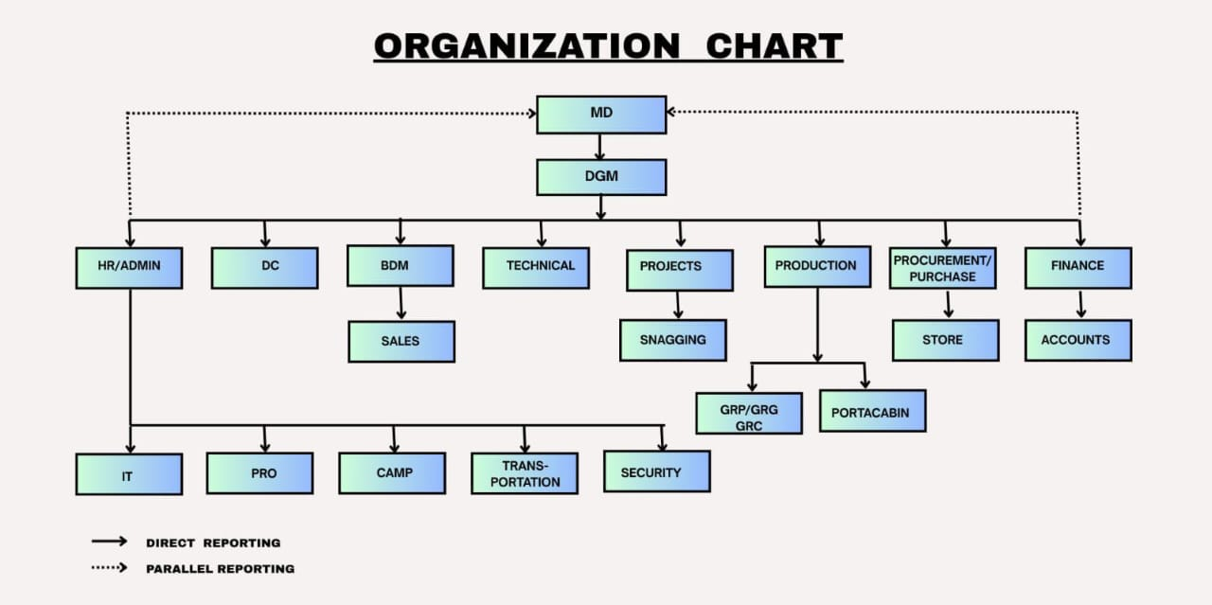

We'd love to hear from you
Stay Connected
Contact us or Talk to our experts, we are always open for a cup of coffee …

- Image Fibreglass Industries LLC, P.O Box 1294 Umm Al Quwain, UAE
- +971 56414 5506
- Image Fibreglass Industries, P.O Box: 239742, Dubai, UAE
- +971

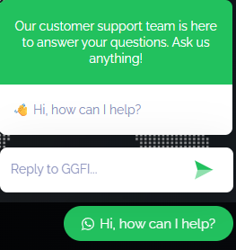
add one direct WhatsApp link to reach out

Call or submit our online form to request an estimate or for general questions about US. We look forward to serving you!
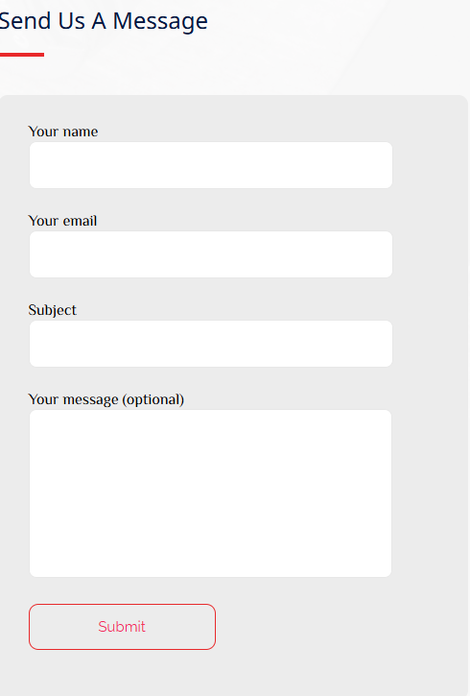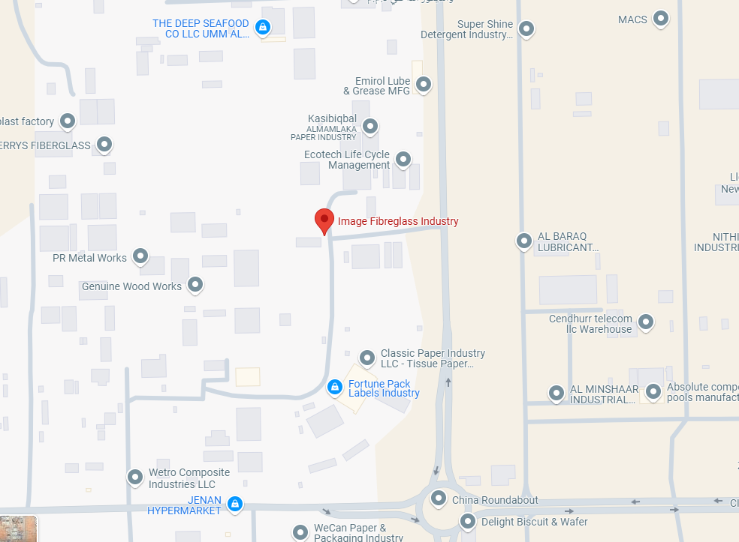
LOCATION

